**.**

**A comprehensive review of computational approaches to the interaction of pyrene derivatives with BSA protein: insights from experimental studies**

SelvarajSengottiyan1,Kakoli Malakar2,Arunkumar Kathiravan3,Marappan Velusamy2,Alicja Mikolajczyk1, Tomasz Puzyn1*

1Department of [Name 1], Indian Institute of Technology Guwahati, Assam, India. 1Laboratory of Environmental Chemometrics, Faculty of Chemistry, University of Gdansk, WitaStwosza 63, Gdansk, 80–308 Poland

2Department of Chemistry, North Eastern Hill University, Shillong 793 022, Meghalaya, India

3Department of Chemistry, Vel Tech Rangarajan DrSagunthala R & D Institute of Science and Technology, Avadi, Chennai-600 062, Tamil Nadu, India.

*Corresponding author, Email: mvelusamy@gmail.com

The work was developed to study the interaction of bovine serum albumin with potent new pyrene derivatives (PS1 and PS2), such as N'-pyrene-1-ylmethylene-hydrazine-carbodithioic acid methyl ester (PS1) and N'-pyrene-1-ylmethylene-hydrazine-carbodithioic acid benzyl ester (PS2), leading to a better understanding of the binding mechanism in truly drug-based applications. Where R= Me/-CH2-Ph is described using bovine serum albumin (BSA) as the medium. From the steady-state fluorescence spectroscopy and fluorescence lifetime-based studies, the binding mode of interaction and binding constants are both 1.12. The experimental results showed that static type interaction play a crucial role in the interaction of the pyrene derivatives with BSA protein. Furthermore, molecular docking and molecular dynamics simulations were performed to predict the mode of interaction and the dynamic behaviour of the two BSA complex dyes PS1 and PS2. Moreover, the free energies of binding for the BSA-PS1 and BSA-PS2 complexes were estimated at 300 K based on the molecular mechanics of Poisson-Boltzmann surface (MMPBSA) with the Gromacs package. It was found that the ~~pyrene derivatives of~~ PS2 have a higher binding affinity than PS1. To find out the behaviour of orbital transitions in the ground state geometry, we found that both dyes have similar behaviour of orbital transitions of HOMO-LUMO from п→п* and HOMO -1-LUMO+1 from n→п*, which was included in the FMO analysis. A cytotoxicity study was performed to determine the toxicity of the dyes. PS2 is more toxic than PS1, and our approaches correlated well with the empirical data. The computer simulations confirmed the results of the experimental studies. This study may be useful to understand the combined toxic effects of PS1 and PS2 on proteins at the molecular level.

**References** }

1. Royer, C.A. Probing Protein Folding and Conformational Transitions with Fluorescence. Chem. Rev. 2006, 106, 1769-1784, https://doi.org/10.1021/cr0404390.

2. Cohen, B.E.; McAnaney, T.B.; Park, E.S.; Jan, Y.N.; Boxer, S.G.; Jan, L.Y. Probing Protein Electrostatics with a Synthetic Fluorescent Amino Acid. Science 2002, 296, 1700, https://doi.org/10.1126/science.1069346

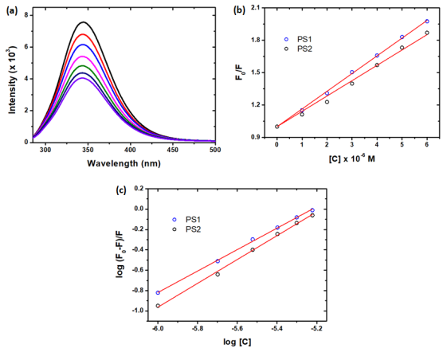

Figure 1. (a) BSA fluorescence quenching spectra with various concentrations of PS2, (b) Stern-Volmer plot for fluorescence quenching, (c)plot between log(F0-F)/F and log [Q]. Figure 2: Interaction of BSAwith(a)PS1 and(b)PS2